

Domestic Abuse Practitioner Standard for Northumbria

Level 1: Domestic Abuse Awareness F2F Training

Handouts and Materials

Contents:
- Pre-course questionnaire
- Course outline / list of acronyms
- Power and Control Wheel / Equality Wheel
- Quiz handout
- Myth or fact statements
- Diversity case studies
- Evaluation and feedback form
- Post-course questionnaire

Pre-course questionnaire
We would like to ensure that the learning outcomes have been achieved on today’s training. Please rate your knowledge and understanding of domestic abuse (DA) and give this questionnaire to the facilitator before the course starts.

Name: Date:
Job title:

To what extent do you agree or disagree with the following 10 statements?
- I can define DA in line with the statutory definition.
  - Strongly agree
  - Agree
  - Disagree
  - Strongly disagree

- I can describe the different types of abusive behaviours used by perpetrators of DA.
  - Strongly agree
  - Agree
  - Disagree
  - Strongly disagree

- I can describe the range of controlling and coercive behaviours that perpetrators use.
  - Strongly agree
  - Agree
  - Disagree
  - Strongly disagree

- I can explain the impact of DA on individuals affected by it.
  - Strongly agree
  - Agree
  - Disagree
  - Strongly disagree

Please turn over

- I can explain the factors that prevent survivors of abuse from leaving abusive partners.
  - Strongly agree
  - Agree
  - Disagree
  - Strongly disagree

- I can describe the prevalence, extent and severity of DA.
  - Strongly agree
  - Agree
  - Disagree
  - Strongly disagree

- I can explain how myths relating to the causes of DA impact on survivors and perpetrators.
  - Strongly agree
  - Agree
  - Disagree
  - Strongly disagree

- I can explain how discrimination in society contributes to the experience and impact of DA.
  - Strongly agree
  - Agree
  - Disagree
  - Strongly disagree

- I can describe the additional barriers that marginalised survivors encounter when disclosing abuse and accessing support services.
  - Strongly agree
  - Agree
  - Disagree
  - Strongly disagree

- I can describe a range of local, regional and national services that can support people affected by DA.
  - Strongly agree
  - Agree
  - Disagree
  - Strongly disagree

Thank you! Please hand this form to the facilitator before the course starts.


Course Outline

Facilitators:
Name and contact details

Time |  | Session | Description
9.15 – 9.30 |  | Welcome, refreshments and registration
9.30 – 10.15 | 1 | Introduction
10.15 – 11.00 | 2 | What is domestic abuse and how does it affect survivors?
11.00 – 11.15 |  | Break
11.15 – 12.30 | 2 | What is domestic abuse and how does it affect survivors?
12.30 – 1.00 |  | Lunch
1.00 – 1.45 | 3 | How prevalent is domestic abuse?
1.45 – 2.30 | 4 | What causes domestic abuse?
2.30 – 2.45 |  | Break
2.45 – 3.45 | 5 | How does domestic abuse affect people from different communities?
3.45 – 4.00 | 6 | What support is available for people affected by domestic abuse?
4.00 – 4.30 | 7 | Conclusion, reflection and evaluation

List of acronyms
APVA / CPVA | Adolescent to parent violence and abuse / Child to parent violence and abuse
ASB | Anti-social behaviour
BAME | Black, Asian and minority ethnic
CAADA | Coordinated Action against Domestic Abuse (now called SafeLives)
CPS | Crown Prosecution Service
CSE | Child sexual exploitation
DASH | Domestic Abuse, Stalking and Honour Based Violence
DHR | Domestic Homicide Review
DA / DVA | Domestic abuse / domestic violence and abuse
DVPN / DVPO | Domestic Violence Protection Notice / Order
FGM | Female genital mutilation
FGMPO | Female Genital Mutilation Protection Order
FM | Forced marriage
FMPO | Forced Marriage Protection Order
FMU | Forced Marriage Unit
HBV / HBA | Honour based violence / abuse
IDVA | Independent Domestic Violence Adviser
ISVA | Independent Sexual Violence Adviser
IPV | Intimate partner violence
LGBT+ | Lesbian, gay, bisexual and / or transgender plus other groups, such as asexual, intersex, queer, questioning, etc.
MAPPA | Multi-Agency Public Protection Arrangements
MARAC | Multi-Agency Risk Assessment Conference (survivor focused)
MATAC | Multi-Agency Task and Coordination (perpetrator focused)
MASH | Multi-Agency Safeguarding Hub
NCRS | National Crime Recording Standards
PTSD | Post-traumatic stress disorder
RC / RIC | Risk Checklist / Risk Identification Checklist
SDAC | Specialist Domestic Abuse Court
SPOC | Single point of contact

POWER AND CONTROL WHEEL

Physical and sexual assaults, or threats to commit them, are the most apparent forms of domestic abuse and are usually the actions that allow others to become aware of the problem. However, regular use of other abusive behaviours by the perpetrator, when reinforced by one or more acts of physical violence, make up a larger system of abuse. Although physical assaults may occur only once or occasionally, they instill fear of future violent attacks and allow the abuser to take control of the woman’s life and circumstances.
The Power and Control diagram is a particularly helpful tool in understanding the overall pattern of abusive and violent behaviours, which are used by a perpetrator to establish and maintain control over his partner. Very often, one or more violent incidents are accompanied by an array of these other types of abuse. They are less easily identified, yet firmly establish a pattern of intimidation and control in the relationship.

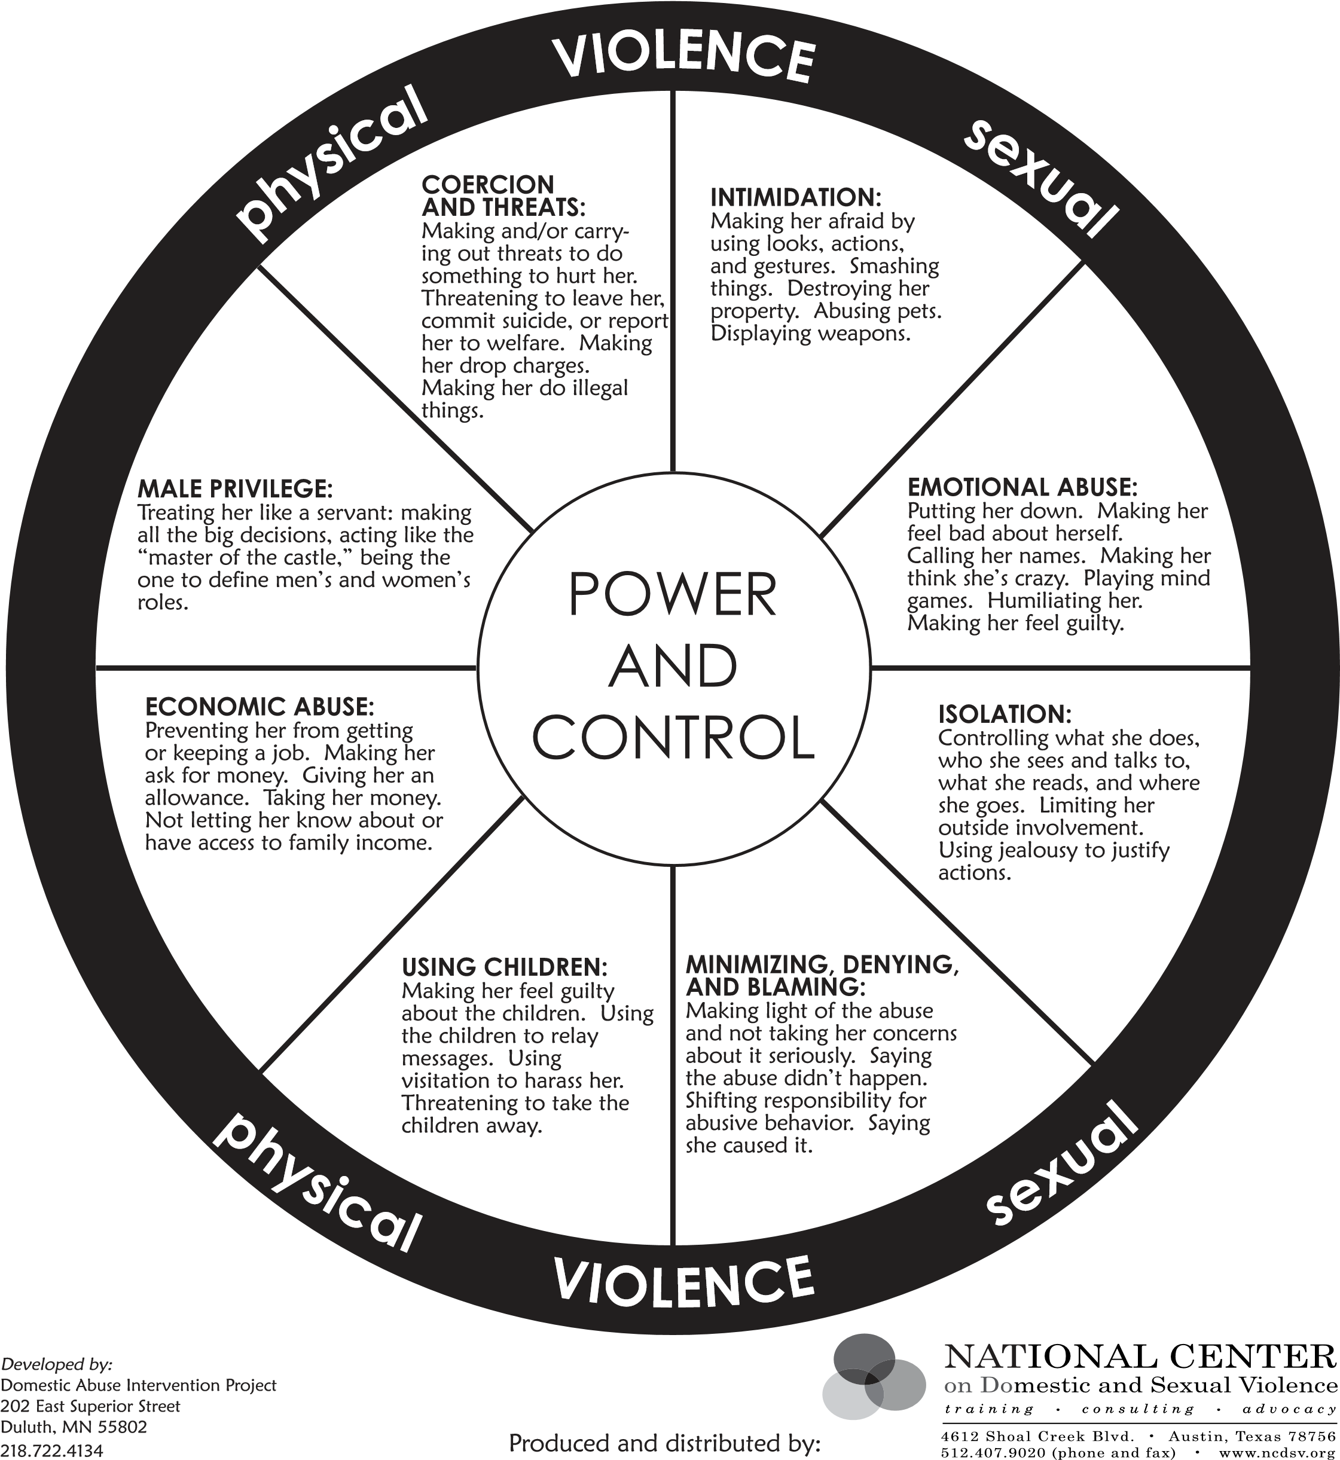

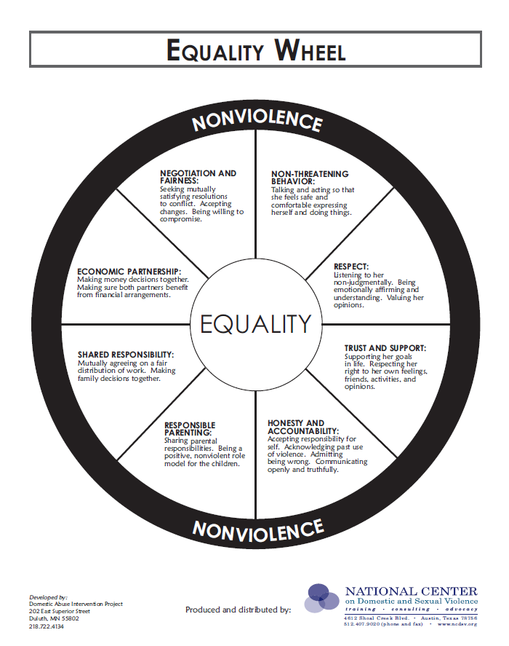

Session 3: How prevalent is domestic abuse?

- In the year ending March 2025, how many people aged 16 years and over experienced domestic abuse in England and Wales?

- 1.8 million b) 2.8 million c) 3.8 million

Office for National Statistics ‘Domestic abuse prevalence and trends, England and Wales: year ending March 2025’

- How many domestic abuse-related incidents and crimes were recorded by the police across England and Wales in the year ending March 2025?

- 1.4 million b) 2.4 million c) 3.4 million

Office for National Statistics ‘Domestic abuse prevalence and trends, England and Wales: year ending March 2025’

- How many contacts related to a possible forced marriage and/or female genital mutilation were recorded by the Forced Marriage Unit in 2024?

a) 212 b) 512 c) 812

Home Office ‘Forced Marriage Unit Statistics 2024’

- How many domestic homicides were recorded in England and Wales between April 2021 and March 2024?

- 352 b) 152 c) 52

Office for National Statistics ‘Domestic abuse victim characteristics, England and Wales: year ending March 2024’

- How many domestic abuse victim suicides were recorded in England and Wales in 2020 – 2024?

- 154 b) 354 c) 554

Home Office, ‘Domestic Homicides and Suspected Victim Suicides 2020-2024’

(Turn over for more questions…)

- What was the estimated cost of domestic abuse in England and Wales for the year ending March 2017?

- £22 million b) £44 billion c) £66 billion

Home Office, ‘The economic and social costs of domestic abuse’ (2019)

- What proportion of children living with domestic abuse are directly harmed by the perpetrator of the abuse?

a) 58% b) 78% c) 98%

SafeLives ‘Marac national dataset’ (2023)

Excessive alcohol and drug use is a major cause of
domestic abuse

Forced marriage is caused by a culture clash between
older and younger generations in a family

Survivors of domestic abuse
must provoke the abuser

In a lot of abusive relationships, men and women are
equally violent and abusive towards each other

Boys who grow up witnessing domestic abuse
in the home are more likely to become perpetrators

Survivors of domestic abuse
usually go from one abusive relationship to another

Anyone could become a survivor of domestic abuse, regardless of where they live or how much money they have
True

Perpetrators of domestic abuse
are very much in control of their anger
True

Brenda is 79 years old and has been married to Charles for 60 years. Charles has recently been diagnosed as being in the early stages of dementia. He regularly verbally and physically attacks Brenda – he has hit her with the TV remote control and her walking stick, bitten her arm and pulled her hair. The household bills have always been in Charles’ name but now he is forgetting to pay some of them and Brenda is becoming increasingly anxious that they are getting into debt.

Adrian has been married to Josie for 5 years. They have 2 children, a baby girl aged 3 months and a son aged 3 years. Josie refuses to do anything for the baby saying she is too tired and she is refusing to allow friends and family to visit or help out. She complains if Adrian goes anywhere leaving her with the children. She can be very verbally nasty and on a couple of occasions she has thrown crockery at Adrian during an argument.

Matthew is a practising Roman Catholic. He has been in a relationship with Brian for 18 months. He has kept this relationship secret from his family as they firmly believe that being gay is against their religion’s teachings. Matthew has decided that he doesn’t want to be in the relationship anymore as Brian is possessive and has an unpleasant jealous streak in him but Brian has started following him to work and threatening to tell Matthew’s parents if he breaks up with him.

Prakash, aged 17, was born and brought up in the UK. Her family are of Indian origin. She is currently studying for her A level’s and has ambitions to become a lawyer. However, her parents have told her that she must marry a distant relative when they visit India in the summer holidays. When Prakash tried to talk to them about why she didn’t want to marry this man, her parents threatened to take her out of school now so she would miss her exams.

Dawn is a transgender woman in a relationship with Neil, her partner. Neil is emotionally abusive towards Dawn, repeatedly refusing to use her preferred pronouns and name. He constantly ridicules her identity, physical appearance and clothes. He tells her that she will never be a real woman and that no one else will ever find her attractive. Neil has also been physically violent towards Dawn on 2 occasions, punching her breasts and kicking her in the groin area.

Fatima came to live in the UK 2 years ago following an arranged marriage to a UK citizen. She lives with her husband and in-laws, all of whom are violent and abusive towards her. She is forced to cook for the whole family, clean the house every day, is never allowed out of the house and isn’t allowed to speak to her family on the telephone without someone else being present. Her husband won’t let her have access to her passport and tells her she will be deported if she tries to leave. She has developed severe depression as a result of her circumstances.

Elaine has been separated from her husband, Ronnie, for 2 years. He was very violent and abusive throughout their 16 year marriage. Since Ronnie left the family home, their 16 year old son, Tom, has also been very aggressive and threatening towards her. Last week Tom threatened to cut her throat with a knife after she challenged him for refusing to go to school. Tom’s behaviour has become much worse since he started seeing his Dad again recently.

Kaylee is 16 and has been seeing her girlfriend Stacey, aged 20, for 4 months. It’s her first serious relationship and she loves Stacey very much. She knows that Stacey loves her too as she gets jealous when Kaylee goes out with her friends. Stacey’s also very generous; she buys Kaylee presents and takes her out clubbing on the gay scene. However, Stacey has started to persuade Kaylee to take drugs and do things sexually that she doesn’t feel ready to do.

